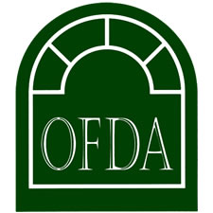

District 13 Fall Meeting

Date: Thursday, September 15th, 2022
Place: Ale House – 1819 (Upstairs)
149 W. Main Street
Lancaster, OH 43130
Time: 4:00 p.m. – 6:00 p.m. FDLIC – 2 CEU’s
6:00 p.m. – 6:30 p.m. Buffet Dinner
6:30 p.m. – 8:30 p.m. OFDA Presentation – 2 CEU’s
Cost: $40.00 per person. Dinner included. Cash Bar Available.
Please make check payable to OFDA District 13.
RSVP: To Tom Theller by Monday, September 5, 2022. By email at tubatheller@gmail.com. Or by regular mail to:
Tom Theller
c/o Taylor-Theller Funeral Home
111 W. Main St. – P.O. Box 176
Amanda, OH 43102
Registration
Licensee Name (Main Contact): ____________________________________

Funeral Home Name: _____________________________________________

Number Attending: _______

